Brâncuși, Constantin (1876-1957)
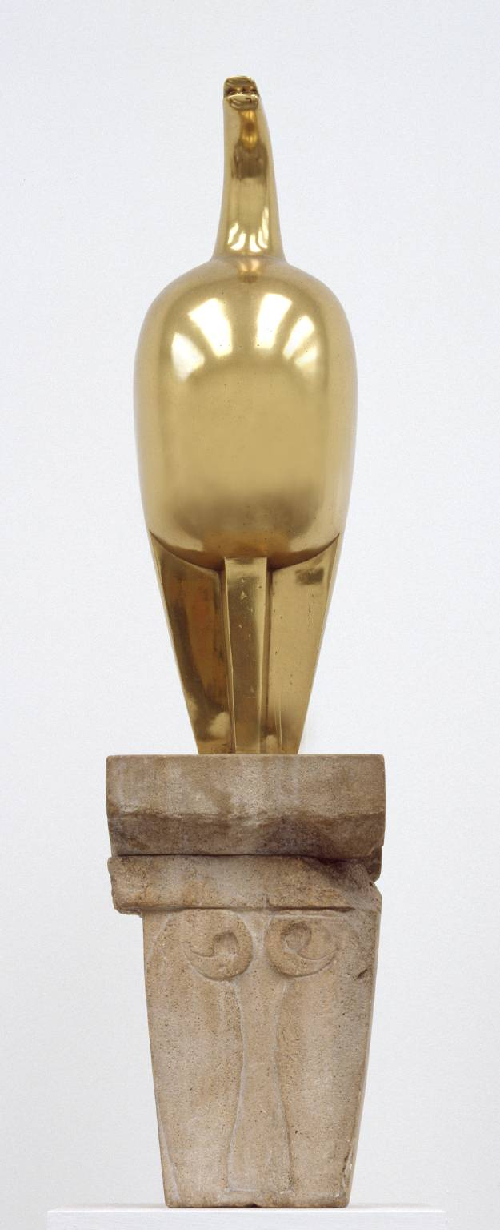
Brancusi, Maiastra (1911)
https://www.tate.org.uk/art/artworks/brancusi-maiastra-t01751

Constantin Brâncuși is one of the great masters of modern and contemporary art. The influence of his work can be felt across both the avant-garde and neo-avant-garde movements. Although he can be considered the early master of minimalism and abstractionism, Constantin Brâncuși admitted to be in the search of realism in sculpture. The extensive work of the Romanian born artist was dedicated, as he claimed, to 'sculpture's own life'. Born in the Romanian village of Hobița in 1876, Brâncuși was profoundly influenced by vernacular philosophy as well as by traditional carving techniques, reflecting a rising European sensibility for the ancestral treatment of the form. In 1903 Brâncuși left for Paris on foot and was admitted there to École Nationale des Beaux-Arts. Refusing to work under Auguste Rodin, he started to develop his own body of work: essentialised forms which condense the search for an archetypal humanism. The Kiss (1907) was one of his first sculptures, which introduced his specific technique of direct carving. Brâncuși chose primordial concepts as titles (e.g.Child, Fish, Prayer, Pride) which reflected his spiritual quest in art. In 1907, Brâncuși worked with Guillaume Apollinaire, Fernand Léger, Amedeo Modigliani and Marcel Duchamp in Montparnasse. In 1913, the first exhibition of Modern Art In the United States – The Armory Show – featured his work.

Brâncuși’s organic forms, the integration of the pedestal into the body of the work, the predilection for tactile textures and purity of form, reveal the influence of African art, the oriental philosophy he was preoccupied with and the teachings of Plato.
Brâncuși returned to Romania in 1938 where he began the Sculptural Ensemble of Târgu Jiu, an open air ensemble, conceived by him as a homage to the Romanian heroes of the First World War. The three pieces - the Table of Silence, the Gate of the Kiss and the Endless Column– represent symbolic forms with which Brâncuși had previously worked: Brâncuși affirmed that the the rhomboidal modules originated in a traditional press screw. Along with historic references attached to each of the three pieces, various religious and esoteric symbolisms have been attributed to the column as an axis mundi, to the stone Table of Silence with twelve seats (as the twelve apostles) and to the entrance gate to the ensemble, the Gate of Kiss, as a gate to the transcendent. Shortly after completing the piece, Brâncuși was declared an enemy of the communist regime for not representing the official 'social realist' style in his work. In 1964, after his death, he was 'rehabilitated' and his work in Târgu Jiu was restored for the first time.
As a consequence of the refusal of the communist Romanian regime to accept the pieces which Brâncuși left after his death in his atelier, the Centre Pompidou in Paris took custody of the work, where they remain on permanent display. Măiastra (1911) is considered his masterpiece: it reproduces a celestial being from Romanian mythology, similar to the Persian Simurgh/Phoenix, the light bird from the Other World. From 1911 until his death, he worked on more than twenty versions of this piece; with the repetition of his fundamental shapes, he introduced the notion of seriality to modern art. He was also responsible for incorporating the plinth into the object, making it an integral part of the work. His famous quote 'Simplicity is complexity resolved' can be considered paradigmatic for the avant-gardes and neo-avantgardes.

SELECTED BIBLIOGRAPHY

Beck E. (2007), Brancusi's Endless Column: Targu-Jiu, Romania (World Monuments Fund), Scala Arts & Heritage, London.

Geist, S. (1969), Constantin Brancusi, 1876-1957: A Retrospective Exhibition, New York. The Solomon R. Guggenheim Museum.

Giedion-Welcker C. (1959), Constantin Brancusi, George Braziller, New York

Gimenez C. and Matthew G. (2004), Constantin Brancusi: The Essence of Things, Tate Publishing, London

Hultén P., Dumitresco, N., Istrati A. Brancusi, (1987) Abrams, New York

Pearson J. (2010), Constantin Brancusi. Sculpting the essence of Things, Crescent Moon Publishing, Kent

Shanes E. (1989), Constantin Brancusi, Abbeville Press, New York.

Varia R. (2003), Brancusi, Rizzoli, New York

